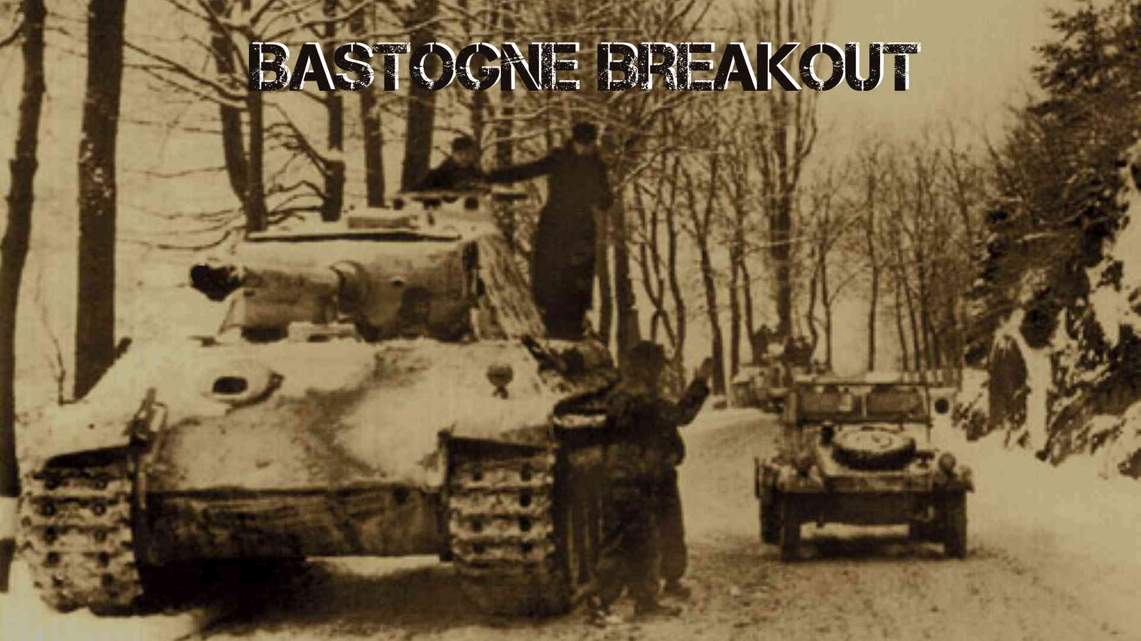

# Bastogne Breakout - Battle Manual

# Introduction

Welcome to the game Bastogne Breakout. This is a simulation of part of the German winter offensive in 1944 called the Battle of the Bulge. Its focus is the south part of the battle over control of the road network around the Belgium city of Bastogne. This was crucial for the breakthrough of the German LVIII Panzer Corp on it route to Namur.

# 1.1 Map

The game is played on a map which is a representation of the actual terrain around Bastogne and Wiltz in December 1944. The map is overlaid with hexagons to govern movement, combat and supply rules. Each hexagon is associated with a specific terrain type which effect movement, supply and combat. Each hex represents 1 mile or 1.6 kilometer across.

# 1.2 Playing Pieces

Playing pieces called Counters represent the actual historical units involved in the battles as well as informational markers. Each playing counter represents an actual unit involved in the battle. They represent battalions, regiments, brigades and kampfgruppen(ad hoc German units). Informational markers are used for Supply sources, Reinforcement entry hexes and Exit areas.

# 1.3 Play Side

Players can choose to play as the German side against the computer(the AI) or play both sides called hot seat mode.

# 1.4 Scenarios and how to win

**Introduction Scenario** - To win this scenario the Germans must control all of the Bastogne and Wiltz hexes. Control means that they must occupy or have been the last to occupy the hex. Allied player wins by avoiding the German conditions.

Future scenarios available in the next releases are:

* **Second Panzer goes west scenario.**
* **Bastogne Breakout scenario,**
* **Counterattack scenario**.

# How to Win

The user must score victory points as defined in the rules see 10.0 **Victory** in the rulebook. The German can achieve major point gains by exiting mechanized units of the north and west section of the map (off to Antwerp and Brussels) and conquering cities or towns. The Allies gain points by eliminating German units.

If playing against the ***Preview Edition German AI*** there are a number of considerations to think about:

* 1. With the overwhelming edge the allied player has by the end of the game, a competent player should be able to retake all the Cities, Towns and Meuse riversides.
  2. The key to an AI victory is Mechanized units that leave the northwest and west edge of the board. These give four points and two points respectively. These points can never be retaken from the AI.
  3. The Allies only get points for destroying German divisions, one point each. This is the reason for the presence of the possible 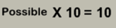 on the Victory Points display. It shows how many German Divisions are in play and therefore how many points can be gotten by eliminating them.
  4. After turn 3 the AI will determine if all the routes to the northwest and west are sealed. If they are it will then start to retreat German divisions off the board.
  5. The Allied player must then count the AI’s player’s victory points that cannot be retaken including allied divisions destroyed. If they are greater or close to the amount of points that can be gained by eliminating all German Divisions then the Allied player cannot win. Quit the game and start over.
  6. Luck plays a large factor in the game at the start of turn 2. If the Allied player’s commanders are not activated before the Germans then there is not much chance of defeating the AI.

# Game Play

The game is played in game turns representing 2 days time. Army and Corp commander units are picked randomly to be activated by the computer. The computer will display all units that can be moved that are in command for the commander. The User can then move and attack with those units. After all units have been played the Computer will pick the next commander to activate. The picked commander can be German or Allied depending on the randomizer see 3.2 **Operations Phase** in the rulebook. At present time if so chosen the AI(computer) can play the German side and handle all processing for that side and score victory points as defined in the rules see 10.0 **Victory**  in the rulebook. The German can achieve major point gains by exiting mechanized units of the north and west section of the map (off to Antwerp and Brussels) and conquering cities. The Allies gain points by eliminating German units.

# Splash Screen

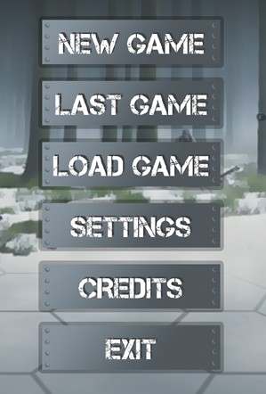After the user start the program, it will load all the elements of the program and after completion the splash screen will be displayed. This screen has six buttons that can be left clicked on by the mouse. The functions available are:

1. **New Game**  left clicking will start a new game based on the current settings; these can be changed by clicking on the settings button
2. **Last Game** if there is a previous non completed game then left clicking will start the game at the last command. This button will not appear the first time the program is run.
3. **Load Game** left clicking will present the Load Game Screen. This screen can be used to continue a previously saved game.
4. **Settings** left clicking will present the Settings Screen. Game variables and scenarios can be changed there. Once a game has started the variable cannot be changed.
5. **Credits** left clicking will display the Credits Screen.
6. **Exit** left clicking will close the program.

# ToolTips

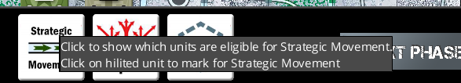Most of the buttons and Icons in the game have information about the button associated with it. These are called Tooltips and can be displayed by hovering over the object with the mouse for a second or two. This is an example of the tooltip for the Strategic Move Button. The Tooltip will disappear when the mouse leaves the button.

# Phase based help

Each new phase entered by the game will display a Help screen. These details what the phase is for and what is expected of the user. 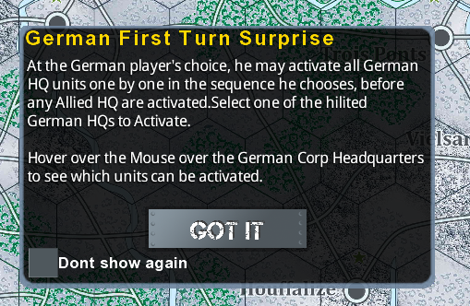 To continue with the game left click on the GOT IT button. If you don’t want this help to appear again, left click the Don’t Show Again box.

* 1. Game Controls
* **Keyboard**
  + Left Key scroll map to left.
  + Right Key scroll map to right.
  + Up Key scroll map upwards.
  + Down Key scroll map down.
* **Mouse**
  + Right Click rearrange units in stack.
  + Left Click initiate button command, select unit, select destination for unit.
* **Windows**

All Windows are movable and the computer will remember where you placed it. Use mouse to grab the title area and move

it.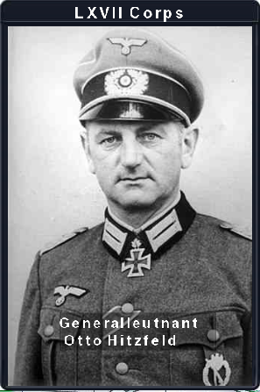 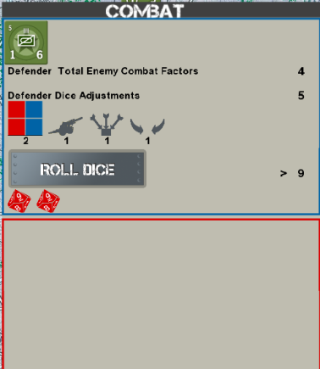

**Title Area**

# Game Map

The game map is graphical representation of the battlefield for the Battle of the Bulge. A hex overlay has been added to regulate movement and combat for the game. The map is larger than the screen size of the monitor. You can zoom in and out by using the mouse scroll wheel or using the + or – keys. The map can also be panned by the mouse or use the arrow keys.

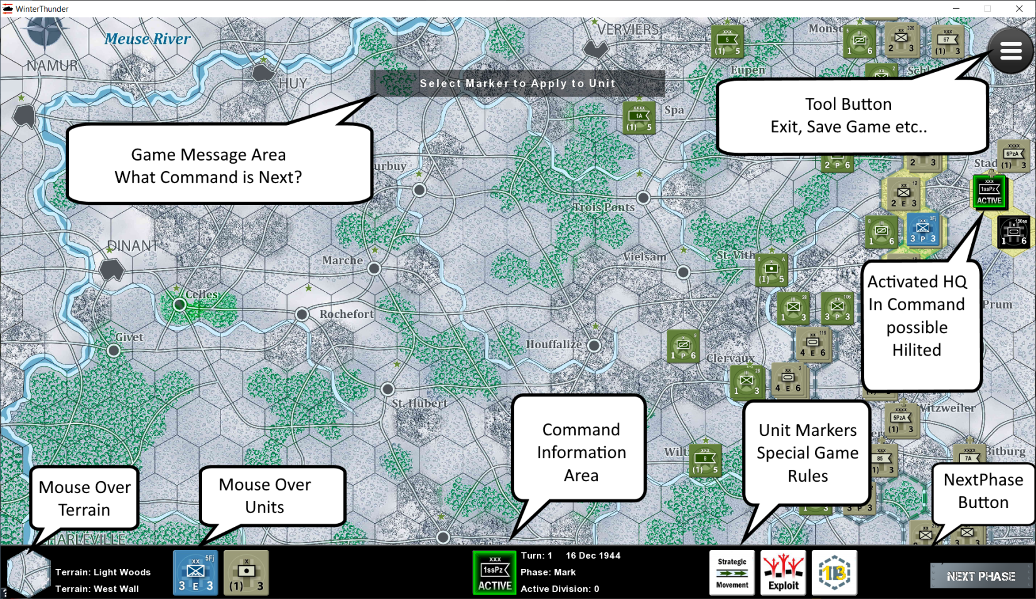

# 2.1 Bottom Command Ribbon



Is used to display information on the current phase of the game. Explanation from left to right:

* Terrain where mouse is hovering,
* Units under where mouse is hovering,
* Corp or Army unit presently in command
* Turn number and date, what phase of command and active divisions for that command.
* In this case we are in the Mark phase so the mark icons are displayed so units can be marked for Strategic Movement, Exploitation and Improved Position.
* The Next Phase Icon used to advance game to next phase.

# 2.2 Highlight of in command Units

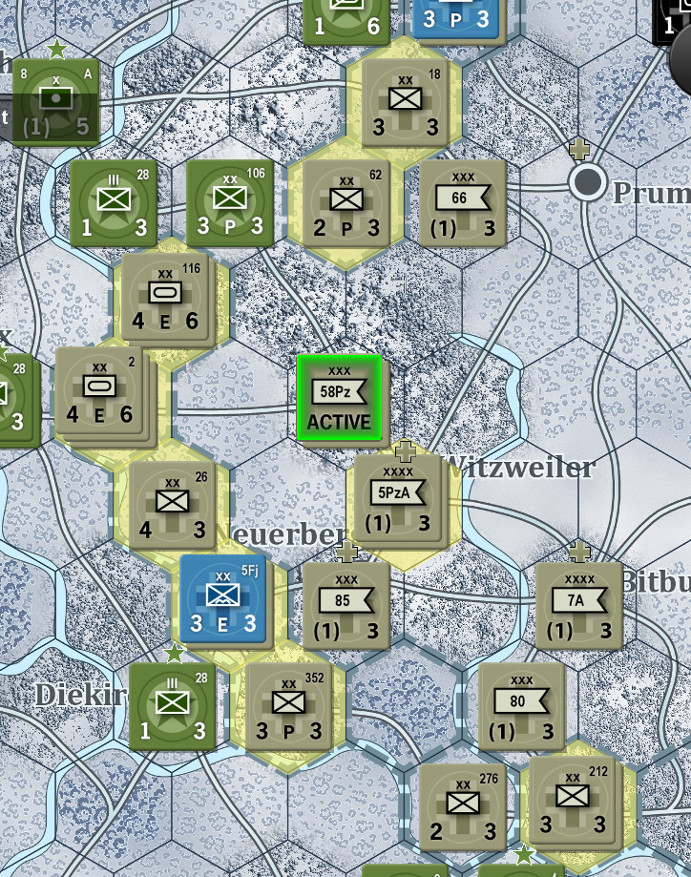Either hexes or units are highlighted to denote the actions that can be taken on units for game purposes. In this case The 58th Panzer Corp has been placed in command. All units that it can command have their hexes highlighted with yellow. This displays the command radius of the corp. On the first turn during the German Headquarters determination a mouse hover will display the highlights.

When it’s the Movement phase all units in command will be highlighted blue.

When it’s the Combat phase all units that can attack will be highlighted red.

* 1. Game message Area

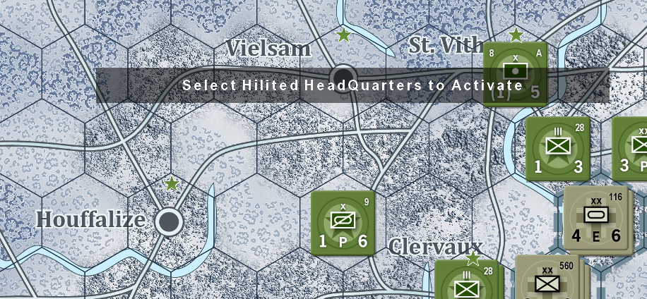The game message gives feedback to the player on what the next step that the program expects from the user. In this case the user one of Headquarters which are highlighted to activate it. When in doubt as to what the computer program wants look at the message area.

# Movement

Once the Movement phase has begun all eligible units will be highlighted blue. The user can left click on a unit to place it in movement mode. The unit will retain its highlight but all others will be turned off. All the eligible hexes that it can move to will be highlighted blue. Left click on the one of the hexes to move the unit to that hex. To Cancel the move click on a non highlighted hex.

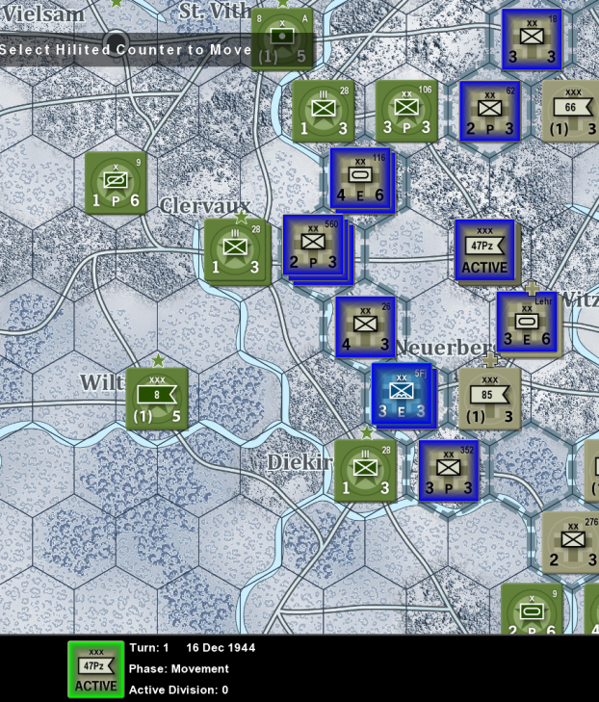In this example the 47th Panzer Corp Headquarters is in command in the movement phase. All units in command and that can be moved have been given a blue highlight.

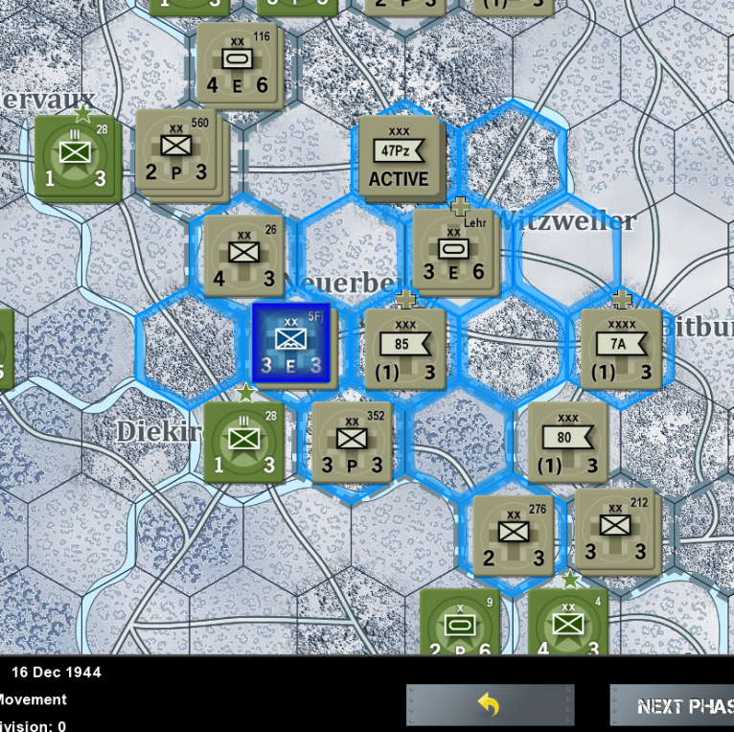

5th Fallschirmjager division has been selected by a left click on the unit. All the hexes it can be moved to are highlighted. To move the unit, left click one of the destination hexes. To undo unit selection Left click on a non highlighted hex.

* 1. **Combat**

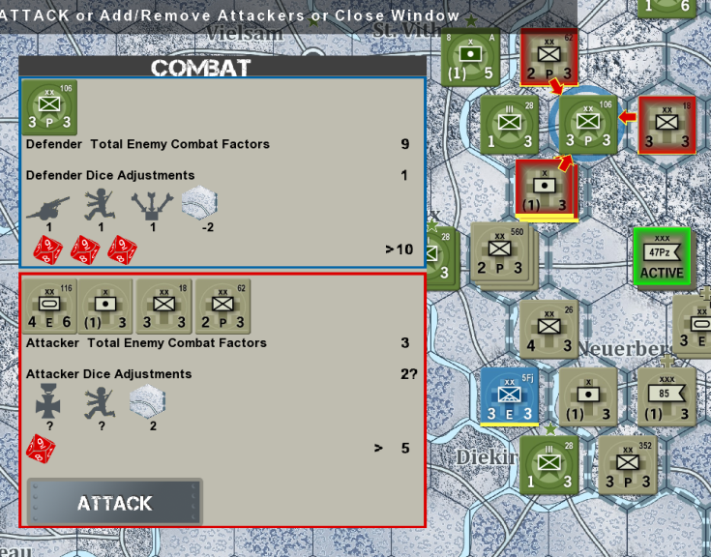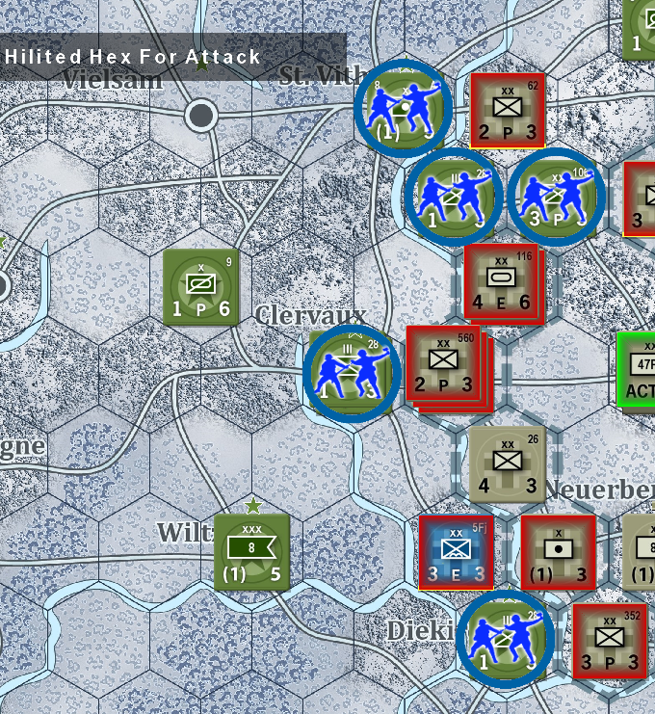In the Combat phase all eligible hexes that can be attacked will be overlaid by the attack Icon. Units that can attack will be highlighted in red. 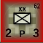 Left click on the attack icon to initiate an attack. All units in that hex will be considered under attack. To cancel the combat just click on the hex to be attacked.

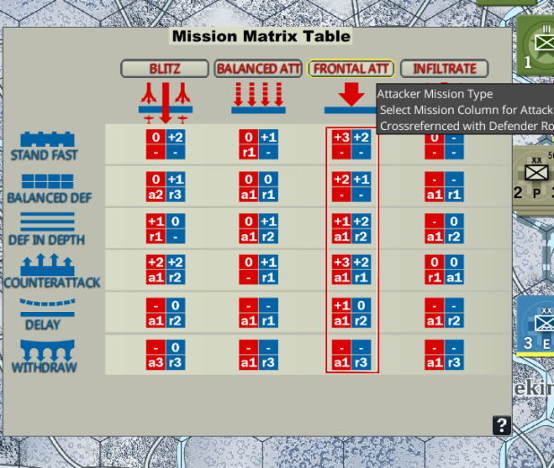When attackers clicked a combat screen will display all attackers and defenders. On the screen the modifiers will be displayed, the ratios calculated and the number to beat shown. Alongside will be the number of ten sided dice to be thrown. Attacker is on the bottom. Defender is placed on the top.

Once the attack is committed, Attack button pressed, the Mission Matrix Table will be displayed and the Attacker and Defender must decide what kind of attack or defense tactic they wish to use.

Once the Mission Matrix has been chosen the Mission Matrix will be displayed on the bottom command ribbon and the user can click the roll dice button. For each dice roll not exceeding calculated total a step loss will occur. Any retreats and advances are applied after losses.

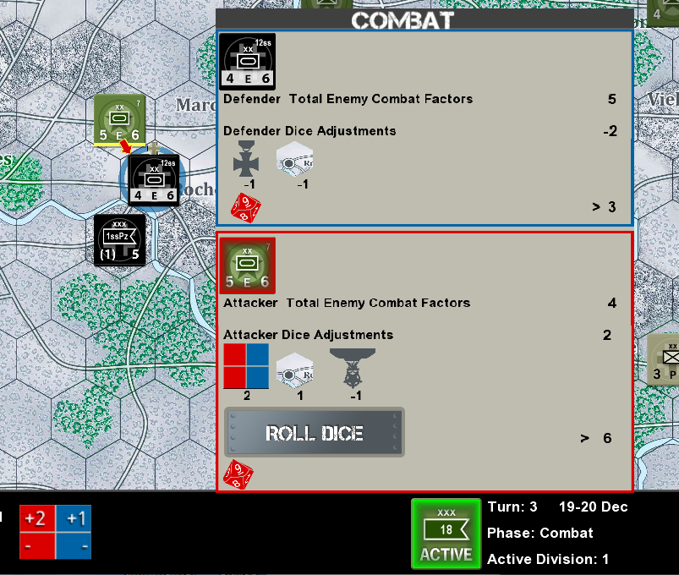

# Game Counters and Hexes

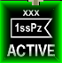 Activated HQ or Possible activated HQ - left click to select activation.

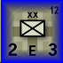 Unit highlighted for move selection or advance or retreat.

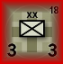 Unit highlighted for attack selection.

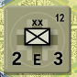 Unit active can be put in command by HQ.

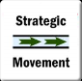 Strategic Movement marker – to be placed on unit to enable strategic movement.

 Exploitation Marker - to be placed on unit to enable Exploitation movement and combat.

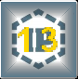 Improved Position Counter – placed on hex to add extra defensive capabilities.

 Block Counter. Inhibits enemy movement.

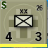 Unit marked for Strategic Movement

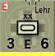 Unit Marked for Exploit Move and Combat

 Hex Highlighted select for Movement, Advance or Retreat.

 Hex Highlighted select for Block.

 Hex selected for Attack.

 Hex Highlighted select to Attack

# Screens

# Settings Screen

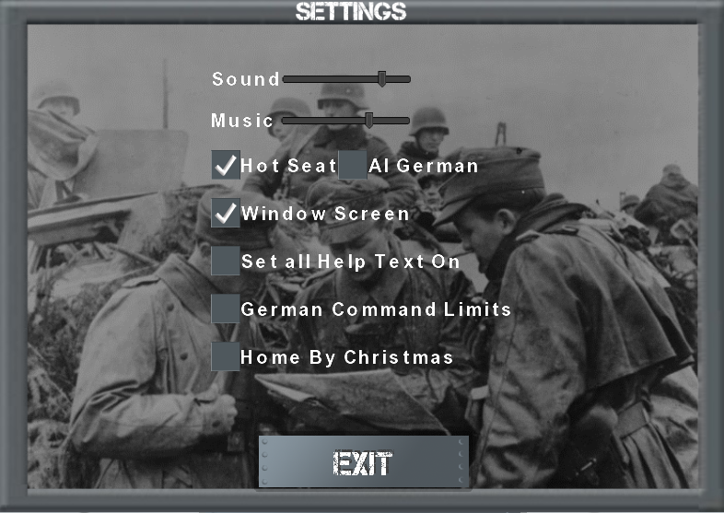Change game parameters which can only be done before game is initiated.

-**Sound Slider** use mouse to adjust volume of games background noise.

-**Music Slider** use mouse to adjust volume of games music at start of the program.

**-Hot Seat CheckBox** set to play game in Hot Seat mode.

**-AI German CheckBox** set to play game as Allies against the German AI. This checkbox is mutually exclusive with the Hot Seat checkbox.

**-Window Screen CheckBox** set to play game in windowed mode. When not checked will play in full screen mode. Maximum resolution is 1920 by 1080.

**-Set Help Text On CheckBox** set to turn on any help screens that have been set to Do Not Show.

**-German Command Limits CheckBox** set to restrict Geram Corp HQs to control only historical units. This will limit German capabilities in the game. Not available yet when German Ai is set.

**-Home By Christmas CheckBox** set to retrict game length to December 25-26th date, turn 6. Not available yet when German AI set.

**- Exit Button** click to go back to main menu. All changes are saved.

# Load Game Screen

Load previously saved game to continue playing

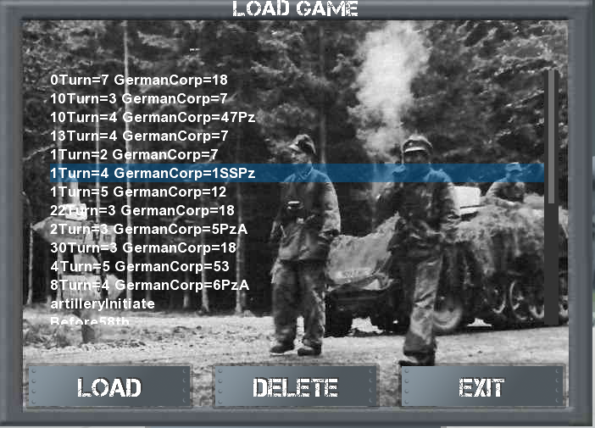**Game selected** will be highlighted with a blue line through it.

**Scroll Bar** at right allows for scrolling through all saved games for selection.

**Load Button** left click to load the game selected and start playing.

**Delete Button** left click to delete the game. It will no longer be available.

**Exit Button** left click to return to the main menu.

# Victory Points Screen

This screen show current victory point status. This the most important screen of the game if you want to win. The allies can only make points by eliminating German divisions. By the end of the game the Allies have an overwhelming manpower advantage if playing against the AI and it should be easy for them to reconquer the cities, towns and throw the Germans off the Meuse. What the allies need to do is prevent the Germans from exiting the north west or west with their mechanized units. See overview on how to interpret results

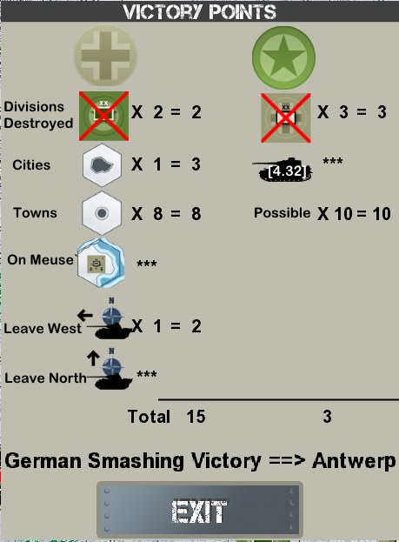

# Problems

No computer program or system is flawless. There might be an occasional problem or bug. Even a couple of missions to Mars failed because of software problems. The rules are not overly complicated but do have some subtleties. I remember spending a couple of days trying to figure out why a panzer unit could not attack the US first army headquarters. It turned out that the panzers were not attacking over a road, which is against the rules.

If there is a problem or the game stops please send a message to info@bruinbeargames and if possible include:

* A description of the problem,
* A screenshot of the problem,
* The file “DEBUGLOG.TXT” which will be in the directory where the game has been stored.

Restarting the game by choosing the LastGame option on the main menu will fix a lot of problems.